In this section, we treat kinematics in which the relative
orientation between two reference frames is time dependent. The time-dependent
relationship between two reference frames is described by the so-called kinematic
differential equations. In this section, we derive the kinematic differ
we derive the kinematic differential equations
for the direction cosine matrix, Euler angles, and quatemions.
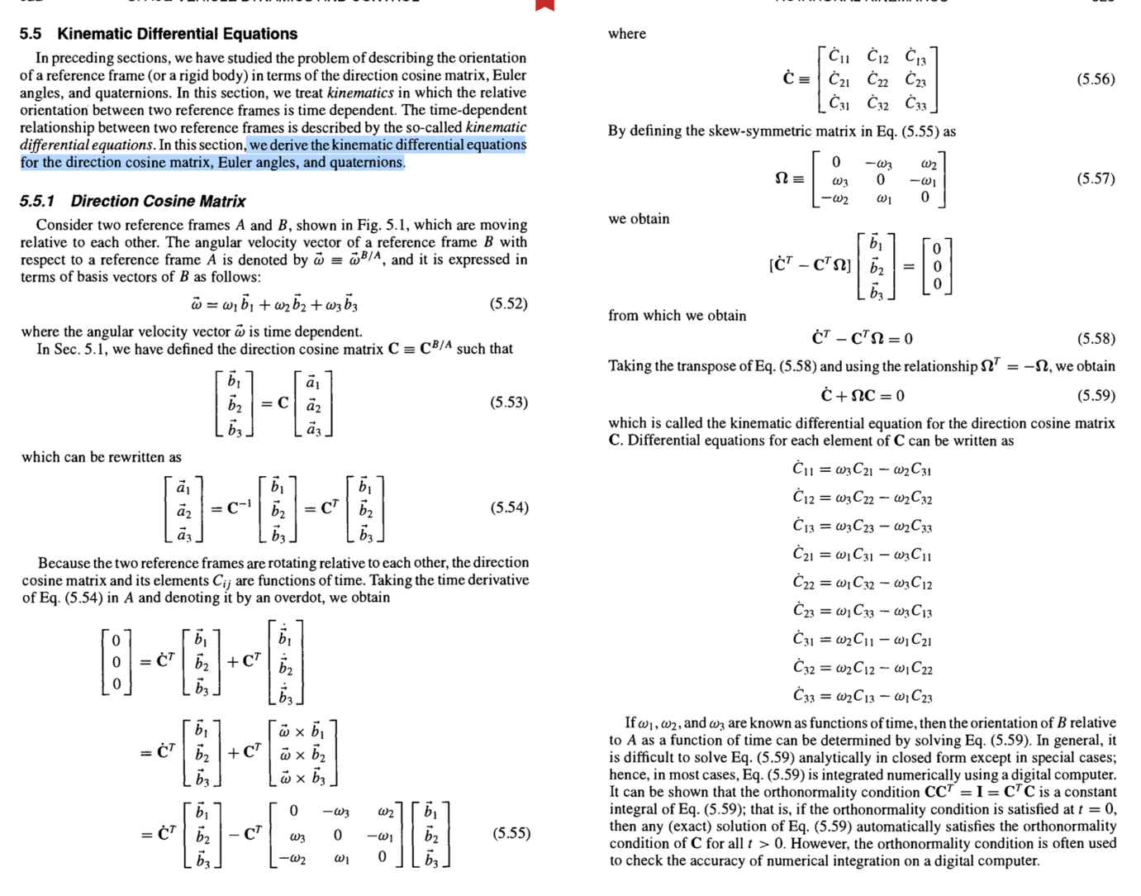

we derive the kinematic differential equations
for the direction cosine matrix, Euler angles, and quatemions.
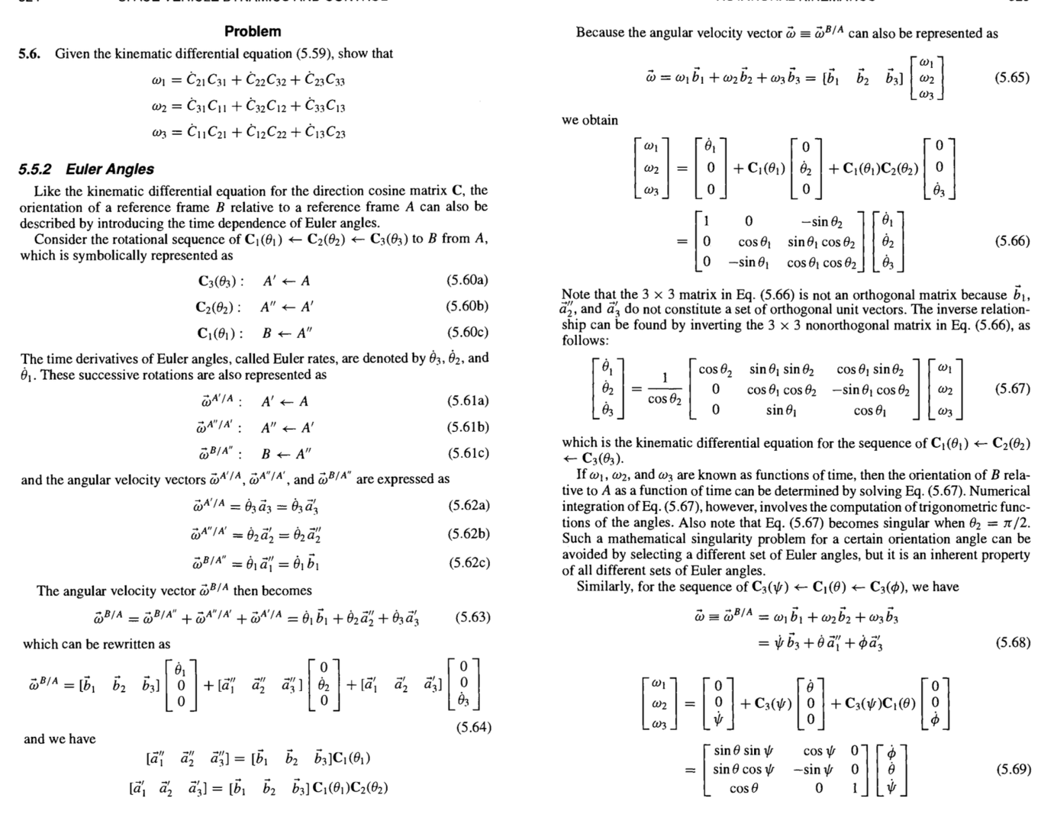

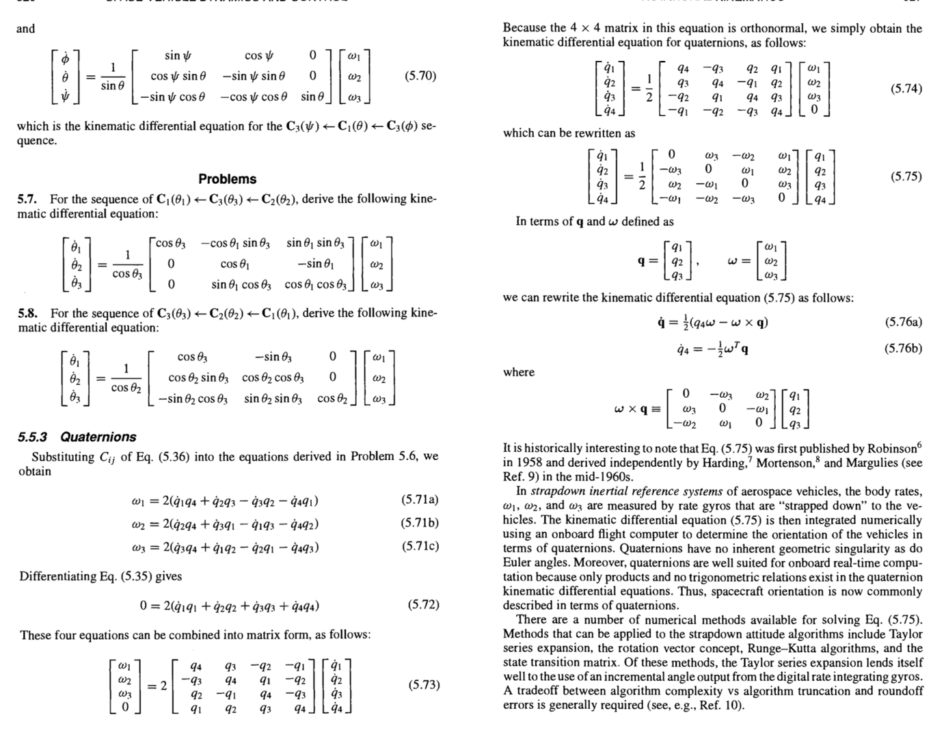

For further details of rotational kinematics and spacecraft attitude determination,
the reader is referred to Refs. 11-15.
Currently, spacecraft attitude determination using the Global Positioning Sys-
tem (GPS) is also being considered for near-Earth satellites. The GPS, consisting
of a constellation of 24 satellites and a ground monitoring and control network,
is widely used for positioning vehicles near the surface of the Earth and for orbit
determination of near-Earth satellites. 16 The GPS is also capable of providing vehi-
cle attitude using L-band carrier phase interferometry between multiple antennas.
Consequently, GPS-based attitude determination is of current research interest for
near-Earth satellites because of the potential for reducing the number of onboard
navigation and attitude sensor

